The Vineyard at 37 High Holly
Proudly presents:
A tour of the Rhone Valley, France featuring the awarding winning wines of Ferraton Peres & Fils Vineyards paired with classic French cuisine from Chef Tim Lundy. Enjoy stunning cheeses, escargot, foie gras, duck breast and bouillabaisse with wines from Cornas, Chateauneuf du Pape, and Saint Joseph to name a few.
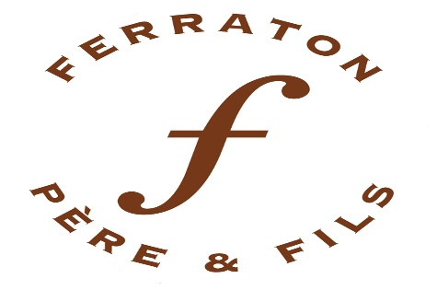
Date: Friday, November 11th, 2020
Start time: 6:30pm
Cost: $150 per person
Address: 37 High Holly Road, Scaly Mountain, NC 28775

Call Rosewood Market for the feasting table seats. Limited availability.
828-526-0383 or rosewoodgourmet@gmail.com

